Exercice 1

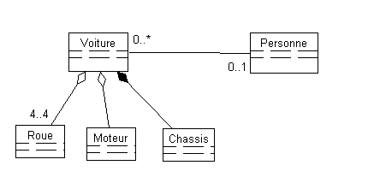

Exercice 2

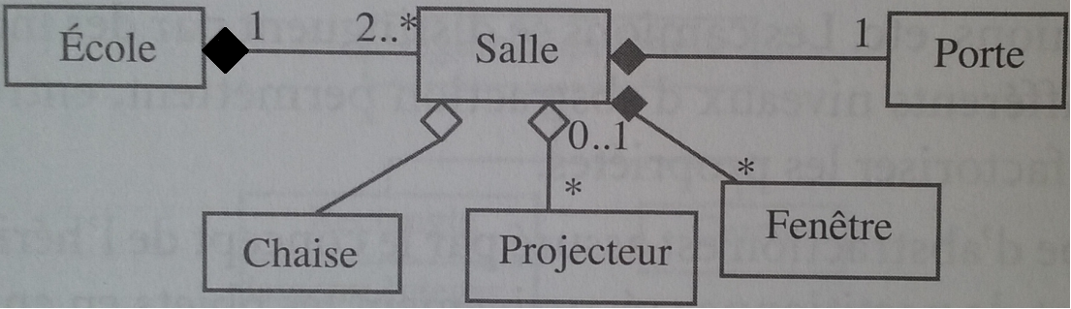

0..1